
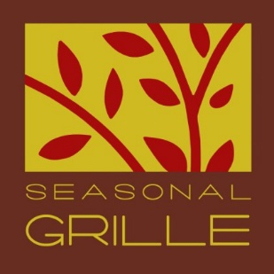

At Seasonal Grille we take every precaution to accommodate your dietary needs due to allergies or medical conditions. Please be sure to inform us of any distinctive needs.

A 50% deposit is required to hold the date of your event. Some portions are non-refundable1. Prices listed do not include tax and gratuity2.

Buffet prices are not based on all you can eat.

All menus must be finalized 2 weeks prior to your event. All invoices (including rentals) need to be paid 7 days prior to your event, unless other arrangements are made with management.

1See Catering Contract
2Gratuity is calculated at 20% and is applied to all food and beverage. Tax is calculated at 6%.

Catering Contract
Seasonal Grille, LLC 150 West State Street Hastings, MI 49058
269.948.9222

Today’s Date:

Agreement between Seasonal Grille, LLC hereinafter called “Caterer” and

and/or hereinafter called “Client”.

Main Contact: Phone: (cell)

Backup Contact: Phone: (cell)

Address: City State Zip Code

Event Type Event Date Event Location

Setting/Style: | Formal | Semi-Formal | Casual
 | Indoors | Outdoors | Kitchen
 | Electricity | Trash Receptacle s | Tables
 | Chairs | Water | Covered Area (Outdoors)
Rentals: | Yes | No
 | Tables | Chairs | Linens (Size/Colors)
 | Dinnerware | Tent | Bar

Event Start Time Event End Time Cocktail Hour Dinner Service

Estimated Headcount Final Headcount (2 weeks prior to event) ___________________

Price per guest $ Price with service and tax* $ Rental Charges $_________________

Anticipated Total $ Deposit Amount $ Date Paid_______________________

*Buffet prices are not based on all you can eat.
*A 50% deposit is required to hold the date of your event. Events are not confirmed until a deposit and signed contract are received.
*A 20% service charge (for travel, setup and cleanup) and a 6% sales and meal tax will be added to all invoices.
*Any additional gratuity is optional, but always appreciated.
*Balance of invoice is due 7 days prior to event, unless arrangements are made with management.

Bills not paid in full within 14 days of the date of the event are deemed overdue and will be assessed a 1.5% interest charge monthly.

1.) It is further agreed as a condition precedent of the agreement that the client will pay a deposit, computed above, on the acceptance of this contract. The deposit is non-refundable less than 7 days prior to the event.
2.) All details of the menu and setup will be listed on this contract.
3.) Client agrees to inform Caterer at least 7 days in advance as to a definite number guaranteed.
Unfilled reservations will be billed. Caterer will prepare for approximately 10% more not exceeding 10 guests.
4.) All food and beverage must be purchased through the Caterer and consumed on premise (excluding wedding cake). Leftover food will not be permitted to leave the premises.
5.) If client requests the caterer to cut and/or serve cake, there will be a $50.00 cake cutting fee.
6.) Should the event be held in a facility with a liquor license held by the client, then all security and/or liquor shall in no way involve the caterer and the client will be responsible for all such aspects of the event.
7.) If event requires a bartender, there will be a $25.00 service fee per hour, with a minimum of 2 hours. 8.) Client agrees to begin function promptly at the scheduled time and conclude at the indicated hour.
9.) Client further agrees to reimburse the Caterer for any overtime wages, payments or other expenses incurred by the caterer because of the client’s failure to comply with these regulations.
10.) Client assumes responsibility for any and all damages caused by any guest, invitee or other person attending event.
11.) It is understood that the client will conduct the event in an orderly manner and in compliance with all applicable laws, ordinances and regulations (and any special requirements of the client set forth in the contract).
12.) In the event of breach of contract by the Client, the Caterer shall keep deposit and client shall be obliged to reimburse Caterer for any damage costs incurred reason of breach thereof, including, but not limited to: lost profits, the cost of any supplies purchased in anticipation of the event and for the contract price of the event.
13.) This contract is contingent upon the absence of accidents or any cause beyond the control of the caterer. The caterer also reserves the right to make reasonable substitutions if unable to secure specific items.
14.) This agreement is not assignable.

Menu
Choices:

Food Allergies/Special Diets/Customs:

Client’s Signature Date

Caterer’s Signature Date ____________________

Boxed Lunches $10.50
All boxed lunches are priced per person and include choice of sandwich or wrap, chips, a sweet, and plasticware.

Sandwich

Cuban Panini

Sliced turkey and ham topped with swiss, pickle, and brown mustard.

Turkey and Brie Panini

Sliced Otto’s turkey topped with baby spinach, roasted red peppers, and brie.

Ham and Dijon with Swiss Panini

Smoked Ham, Swiss cheese, baby spinach, and Dijon, and sliced tomato.

Turkey and Cheddar with Honey Mustard Panini
Ottos turkey, sliced cheddar, green leaf, and honey mustard.

Portobello Panini
Sliced mushrooms, roasted red peppers, onions, pesto, swiss cheese and balsamic glaze

Triple Threat
Ham, turkey, swiss, cheddar, mayo, lettuce, tomato, and bacon between flatbread

Wraps

BBQ Chicken Wrap
Crispy Chicken. BBQ sauce, Cheddar cheese, red onion and baby spinach.

Ham and Swiss Wrap

Honey smoked ham with swiss, brown mustard, baby spinach, and sliced tomato.

Turkey Bacon Ranch Wrap
Sliced Otto's turkey with lettuce, tomato, smoked bacon, cheddar cheese and ranch dressing.

Caesar Wrap
Grilled chicken, parmesan cheese, romaine lettuce, tomato and house Caesar dressing.

Greek Wrap
Crispy chicken, romaine, olive, red onion, tomato, cucumber and feta cheese.

Buffalo Chicken Wrap
Crispy chicken, buffalo sauce, blue cheese crumble, lettuce, tomato

**add a salad for $2.00 more

Lunch Box Salad Options:

House Salad
Spring mix, parmesan cheese, red onion, grape tomato, cranberry, and toasted almond.

Greek Salad
Kalamata olives, cucumber, grape tomato, red onion and feta on romaine lettuce with Greek Vinaigrette.

Caesar Salad
Romaine lettuce, grape tomato, kalamata olive, parmesan cheese and house made croutons with creamy Caesar.

Greek Pasta Salad
Pesto Mayo, almonds, red onion, feta, sundried tomato, and pasta.

Dressing Options
Lemon Sage Vinaigrette, Ranch, French, Tuscan Ranch, Fuji Apple Vinaigrette, Caesar, Oil and Vinegar, Greek, Bleu Cheese, Strawberry Vinaigrette(Seasonal), and Parmesan Cream.

Gluten Free Dressing Options
Lemon Sage
Strawberry(Seasonal)
Greek
Oil and Vinegar

Lunch Buffet Selections:
All selections are priced per person. Selections are not all you can eat.

Deli Buffet with Soup and Salad $13.00 a person

Build Your Own:

Honey Smoked Ham, Oven Roasted Turkey
Swiss, Cheddar and Chef Choice Cheeses
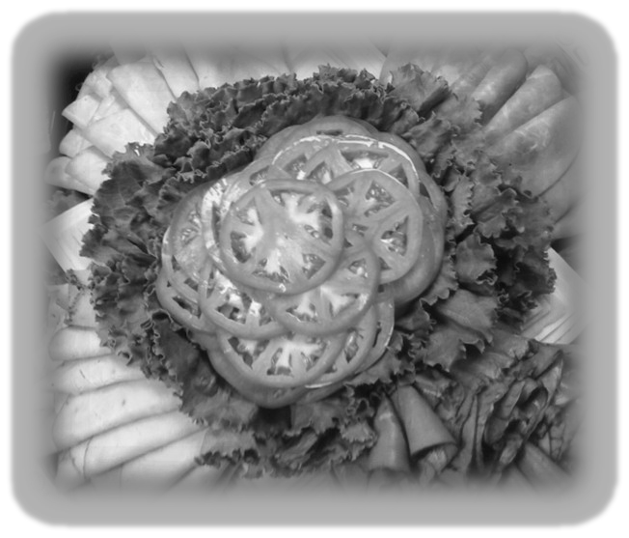
Whole Wheat and White Breads
Lettuce, Tomato, Mayo, and Mustard
Tuscan Chips

Soup options:

Sweet Tomato Bisque (Vegetarian)
Tuscan White Bean with Chicken
Chef’s choice

Salad and Dressing options:

House, Caesar, or Greek Salads

Dressings:
House Lemon Sage Vinaigrette, Ranch, French, Tuscan Ranch, Fuji Apple Vinaigrette, Caesar, Oil and Vinegar, Greek, Bleu Cheese, Strawberry Vinaigrette(Seasonal) and Parmesan Cream.

Continued
Baked Potato Bar 10.00

Idaho baked potatoes served with options of cheddar cheese, sour cream, butter, steamed broccoli, chopped bacon, and chive.

Served with your choice of Salad:

House, Caesar, or Greek Salads

Dressings:
House Lemon Sage Vinaigrette, Ranch, French, Tuscan Ranch, Fuji Apple Vinaigrette, Caesar, Oil and Vinegar, Greek, Bleu Cheese, Strawberry Vinaigrette(Seasonal)

Taco Bar (figured at 3 tacos per person) 12.00

Ground Beef (Add chicken, shrimp, or steak for and additional charge)

Soft Shell Tortillas, cheddar cheese, sour cream, shredded lettuce, tomato, salsa, jalapeno, Spanish rice, refried beans.

Salad Bar 10.00

Mixed Field Greens or Romaine Lettuce

Choice of 2 Dressings:
House Lemon Sage Vinaigrette, Ranch, French, Tuscan Ranch, Fuji Apple Vinaigrette, Caesar, Oil and Vinegar, Greek, Bleu Cheese, Strawberry Vinaigrette(Seasonal)

Shredded Cheese, Chopped Eggs, Ham, Turkey, Red Onion, Grape Tomato.

Ciabatta Bread

Pasta Buffet Selections
Includes choice of one entrée, salad, and dinner roll 18.00 add chicken or sausage for $3.00 a person

Seasonal Grille Lasagna
Baked Ziti with Bell Pepper, Onion and Mushroom
Cheese Tortellini with Pesto Cream (Vegetarian)
Manicotti Al Forno (Vegetarian)
Fettuccine Alfredo with Broccoli
Pasta Pomodoro with Wild Mushrooms (Vegetarian)
Cavatappi with Wild Mushroom Cream (Vegetarian)
Spaghetti and Meatballs
Pasta Primavera (Vegetarian)

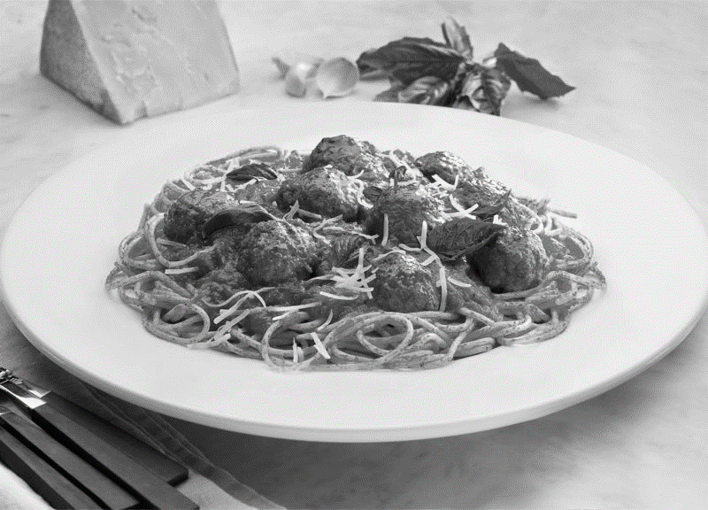

Entrée Buffet Selections
Buffet include your choice of one vegetable and one starch, salad option, and roll.

Beef:

Grilled Sirloin with Herb Butter
Sliced Beef with Mushroom Demi
Peppercorn Crusted Beef
Gorgonzola Beef with Caramelized Bleu Cheese
Beef Short Rib with Cabernet and Mushroom
Dry Rubbed Beef Brisket

Pork:

Pancetta and Pork Roulade with Parmesan
Grilled Smoked Pork Chop with Exotic Mushroom
Roasted Tenderloin with Sautéed Chardonnay Apple
Bacon Wrapped Pork Loin with Marsala Butter
Citrus Marinated Pork Tenderloin
Chipotle Cinnamon Roasted Pork Shoulder
Pork Milanese (Panko and Parmesan Crusted)

Chicken:

Chicken Marsala
Crispy Chicken Parmesan
Chicken Florentine with Balsamic Reduction
Citrus Marinated Grilled Chicken
Bacon Wrapped Chicken with Boursin and Dijon Cream
Herb Grilled Chicken
Mediterranean Chicken with Artichoke and Lemon
Chicken Scaloppini with Caper and Chardonnay Butter

Buffet Side Selections

Vegetable:

Green Beans
Glazed Baby Carrots
Herb Roasted Asparagus (Seasonal)
Roasted Seasonal Medley (Zucchini, Squash, Tomato, Red Onion)
California Blend (Broccoli, Cauliflower, and Carrot)
Steamed Broccoli
Basil Buttered Sweet Corn Kernels
Parmesan Cauliflower Florets
Balsamic Brussel Sprouts ( Red Onion, Balsamic Glaze)

Starch:

Dill Roasted Redskins
Rice Pilaf
Cheddar Bacon Smashed Redskins
White Cheddar Mashed
Roasted Garlic Smashed
Oven Roasted Yukons with Rosemary
Wild Rice with Almond
Gorgonzola Smashed Redskins
Braised Fingerlings with Thyme
Roasted Garlic Potato Wedges
Scalloped Potato
Baked Baby Bakers

Salads:

House, Caesar, or Greek Salads

House Lemon Sage Vinaigrette, Ranch, French, Tuscan Ranch, Fuji Apple Vinaigrette, Caesar, Oil and Vinegar, Greek, Bleu Cheese, Strawberry Vinaigrette(Seasonal) Parmesan Cream.

Appetizers Selections
Choice of 4 options, unless priced separately, are 12.00 a person.
Each additional option is 3.00 each. This does not include tax and gratuity.

Hot

Bacon Wrapped Scallops ($2.00 each)
Chicken Satay with Bourbon Sauce ($1.50 each)
Beef Satay with Traverse City Cherry BBQ
Meatballs with Sweet Chili Sauce
Bacon Wrapped Chicken Bites
Spinach and Artichoke Dip
Crab and Feta Dip
Deep Fried Ravioli with Marinara
Traverse City Cherry BBQ Meatballs
Stuffed Mushrooms with Apples and Sausage
Phyllo Wrapped Asparagus ($1.50 each)
Mini Osso Bucco ($2.00 each)

Cold

Cucumber with Smoked Salmon
Smoked Salmon Filet with Caper, Onion, Cream Cheese and Lemon (market price)
Caprese Skewers with Grape Tomato, Olive, Mozzarella ball and rich EVO
Fresh Fruit Display
Domestic Cheese Display
Imported Cheese Display (Market Price)
Array of Fresh Vegetables, with Dill Aioli
Shrimp Shooters ($2.50 each)
Sandwich Sliders ( Turkey and Ham)
Assorted Hummus with Grilled Flatbread
Boursin Cheese with Crostinis or Chips
Deviled Eggs with Goat Cheese and Boursin
Hard Salami and Provolone Sticks
Antipasti Platter: Peppadew Peppers, Hard Salami, Mozzarella, Kalamata Olive, Spanish Olive, Pepperoncini, Artichoke Hearts ($60.00, feeds 40 people)

Desserts $2.50 each (Small)

Bistro Chocolate Mousse
Turtle Cheesecake
Red Velvet
Bistro Lemon Cloud
Bistro Tiramisu
Brownie Bites
Assorted Cookies
Bistro Cheesecake

Desserts 4.00 (Large)

Raspberry Torte
Chocolate Layer Cake
Cheesecake
Cannoli
Vanilla Bean Cheesecake
Black Forest Cherry

Don’ Forget the Sweets!

Breakfast Buffet

Continental Breakfast: $8.00

Assorted Danish
Muffins
Yogurt
Fresh Fruit
Coffee
Juice

Americano Breakfast: $10.00

Herbed Redskins
Scrambled Eggs
Bacon or Sausage
Fresh Fruit
Danish
Muffins
Yogurt
Water, Juice, Coffee

Oatmeal Bar: $8.00

Dried Cherries
Diced Cinnamon Apples
Chocolate Chip
Pecan Pieces
Fresh Blueberries
Banana

Omelet Station: $12.00

Farm Fresh Eggs,
Cheddar Cheese,
Diced Onions
Red and Green Pepper
Fresh Mushrooms,
Spinach,
Ham
Tomatoes





Testimonials

“Working with Justin Straube and the Seasonal Grille team is always a pleasant experience.
They handle catered events so efficiently and professionally that the event runs
smoothly. Meals are always presented beautifully and are delicious. I recommend Seasonal Grille for all your catering needs.”

Sarah Kollar Hastings MFG.

“Doug and I would love to share with your customers what outstanding, professional, and friendly service you provide for home catering.”
“Not only is the service exceptional but the menu selected with the approval of your client and it's delivery of appealing, presentation, and deliciously flavorful foods are a joy to share with ones guests in the warmth of one’s own home.”
“We have used Seasonal Grille many times and would endorse them and their team for any home catering event.”
“They will not let you down and will help with setup, serving, and cleanup, a great way for the cook to stay out of the kitchen and entertain her guest refreshed and at ease.”

Doug and Margaret DeCamp

“Justin and the Seasonal Grille prepared and catered a superb dinner for our Gourmet Din- ner Club of ten people. The meal was excellently prepared and presented. Justin assisted us in paring the wine which made our dinner experience exceptional. If you want to have a great dinner in your home and have time to enjoy the experience, ask Justin to do it. We had a great time watching him prepare the food and add the finishing touches.”

Jim and Barbara Toburen

Partners:

2. Barry Community Foundation | 269-945-0526
3. Heritage Banquet & Conference Center | 269-685-4015
4. Gilmore Car Museum | 269-671-5089

